**Git by Tushar in Jan’ 2021**

**Git** is a common component. It is a central place were put our work where we can read other people work and add to it. We can share our work. It is a **shared repository**. Repository means central storage. We can collaborate. It is a version management. Every time when I make a change, I made a version. Version number changes whenever changes are made. Git is also known as the version management – meaning what can go in or not, what changes to make or not? Git is an essential component for software development. It is an **open source**, free of cost.

**Version control**, also known as **source control**, is the practice of **tracking and managing changes** to software code. Version control systems are software tools that help software teams manage changes to source code over time.

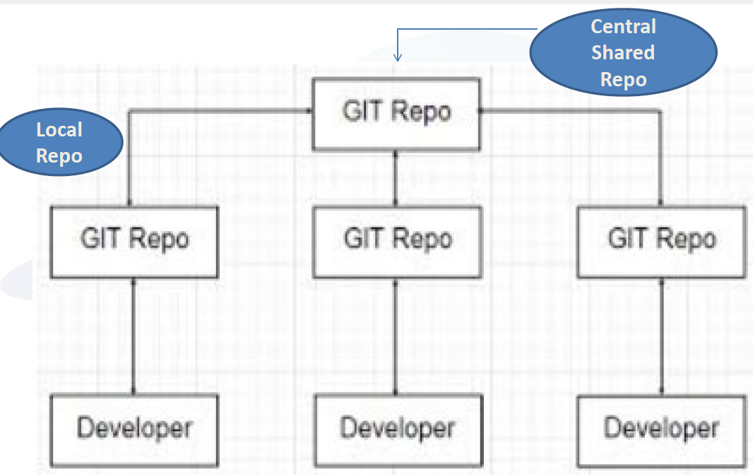 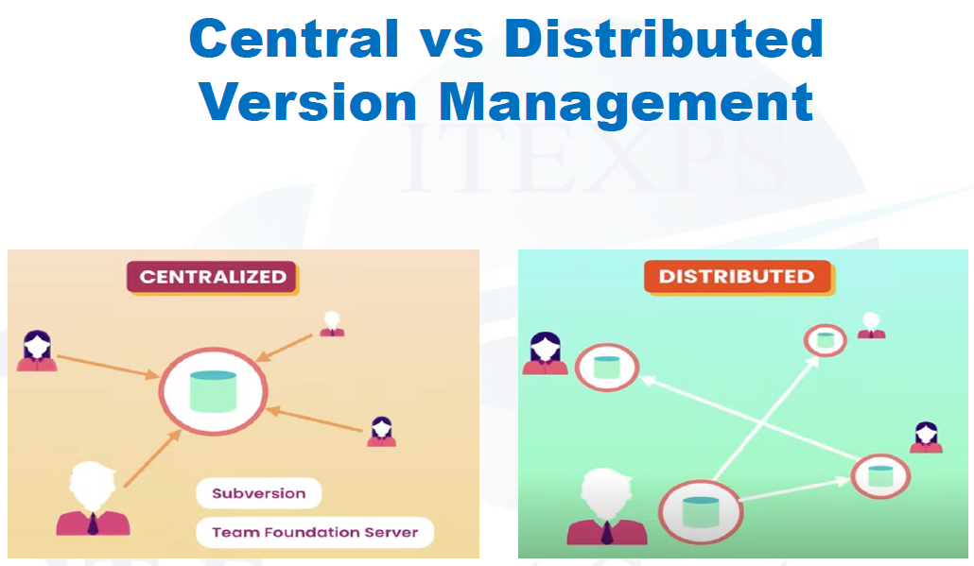

**Why Git?** – it is free, is open source, super-fast, scalable and cheap branching / merging. Git repository is the central part, for which you need to have central location. Central location is the central repository which is called Git repository (means storage). Every company have their Git repository. During this selenium training we are going to make it public because we all want to interact with each other. Uniform resource location (URL) is given by the company. Git repo is shared, with which we interact almost every day. Some companies still use SVN – Software Version Management (it is more centralized). Before Git (is more distributed), it was extremely popular. Git has 2 step approach. It will put everything in central repository and will also put everything in your local machine which is also a repository and is called staging area. It is a mirror of the central repository.

We need to know to use command line, GUI and NetBeans or Eclipse to do Git.

GUI – graphical user interfaces.

Click on plus sign and click on new repository. All lower case.

What is ignore –When there are certain things in the machine which we do not want to put in the repository because we know it is the garbage, it is not important or of no use. We use add.gitignore.

To start we need to do the following thing: -

1. **Git hub account** – Create an account. How to create a new repository in Git. Click on the plus sign to create a new repository. Per project you can have only one repository.

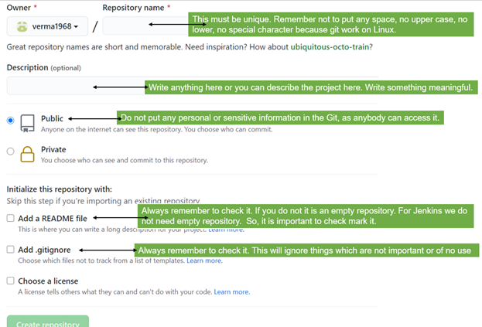

Meaning admin will create one repository and he/she will invite people to work with. There is a special URL which needs to remember. That URL is the repository. Till now we have created repository name.

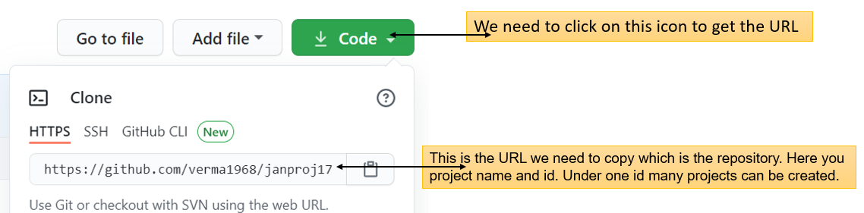

1. Git client (install) – Install it on your machine. It will show as Git bash.click on it to write prompt.
2. Command lines – We will learn commands. This will help us to read and write command. Commands have three things – commands, options, and parameter.

We you open the bash; you will see a dollar sign after the first line. This dollar sign means prompt which means begin. Remember –

* It is case sensitive.
* When you create a file name you do not create a space in between.
* Commands are always lower case.
* After each command there must be single space.
* No spelling mistakes.

1. NetBeans / Eclipses integration with Git – These are software which will help us to write java programs.

Using Git bash: -

1. First in the command box we will write **git** all lower case after the dollar sign. This will give us lots of information.
2. After this step we need to write **git** followed by one space, then write **clone** followed by a space finally right clicking and **pasting the URL**. .
3. Now write **cd** **(change directory)** followed by a space and then only the **repository name** or we can write ‘cd jan & then presses the tab key on the keyboard & press enter. This will write the full name.  Now press the enter.
4. With this we are inside the directory. Here type in **pwd (present working directory)** and press enter. We can do pwd at any point of time to check the directory name. This will give us the directory name and ensure that we are inside it-> 
5. Now we want to see what is inside. We will write ls (LS – means list) 
6. To come out of the project type **cd ..** (cd space dot dot). 
7. To check whether you are out of the directory type in pwd and you will see it does not give directory name.

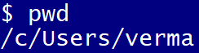.

1. When we enter the project name () we see only one file in it 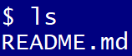.
2. Let learn to add a new file to it from local machine to server. To do so we need to know some Linux command. Here first **we will use** **echo** “this is my first file”. Basically, you can write what you want to add as a new file. Followed by a space, then redirect which is a greater than sign >, then again, a space and then my file.

 my file is the file name we are creating. Now press enter.

1. Now to check whether it is added, type li and press enter. You will see the new file name..

It is important to understand that we clone the URL from Git here. This formed the staging here. Now we added 2 new files to it. Now the staging is different from the server.

1. We need to check the status at this point of time. For this we need to type in **git space status**. Press enter.

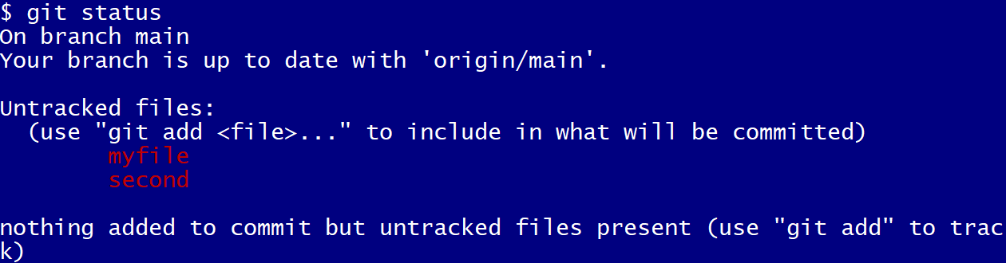

1. Here you see that we created 2 new files in red color, but we need to add it to the server.
2. To add we need to put the command git space add space dot(.) This will add the file. Press enter.

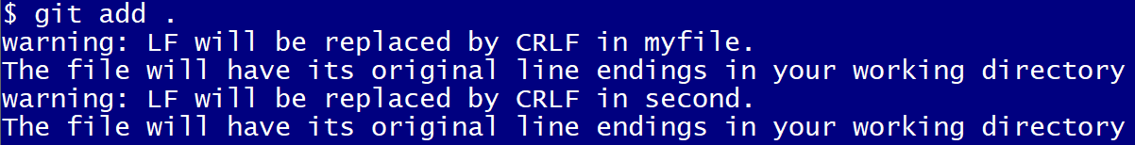

1. Now type in again - **git space status.** Now you will see those two files in green color.

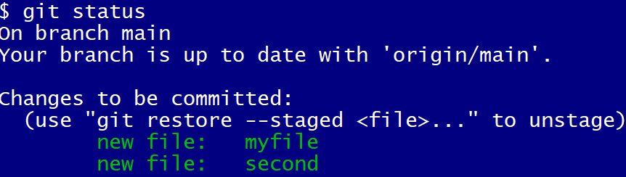

1. Now we must do commit. It means I am confirming that this is something I have done and now I want to push it to the server.

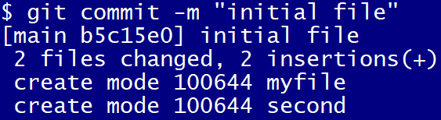

1. Now if we say git status it will show no files. It prompts us that we need to use git push to publish.

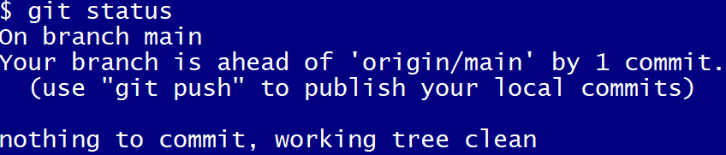

1. Important, you may get a message “to shut your account, please tell me who you are and so on”. For this see the slide which says Git Configure. Remember to do this right.
2. The last step – write git space push and press enter. It will give this message –

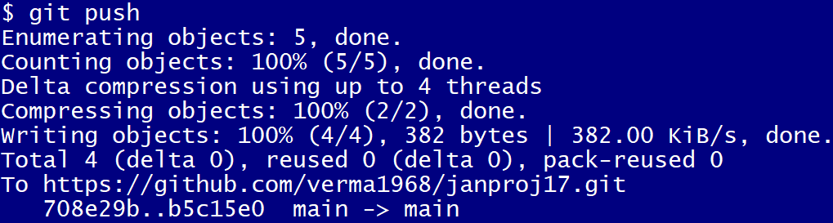

1. We can also do GUI. We can create a file say ‘new’ in the download folder and drag it from there to the Git repository. It will show this message –

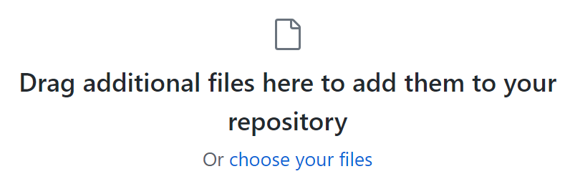

You will see it is now added.

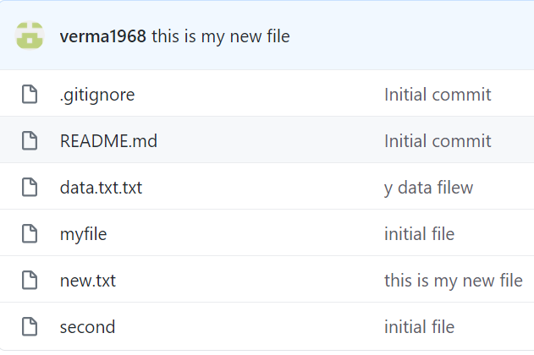

1. From the Git repository we can pull that drag fill by typing git space pull

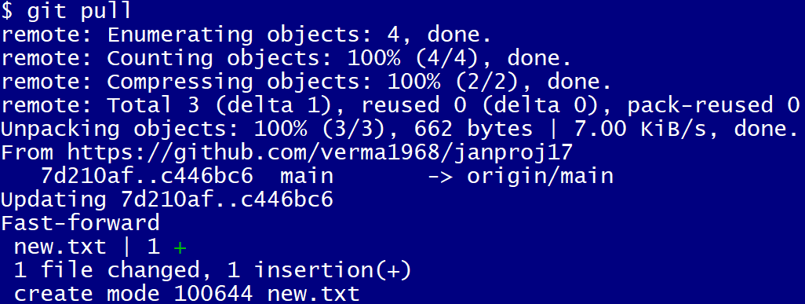

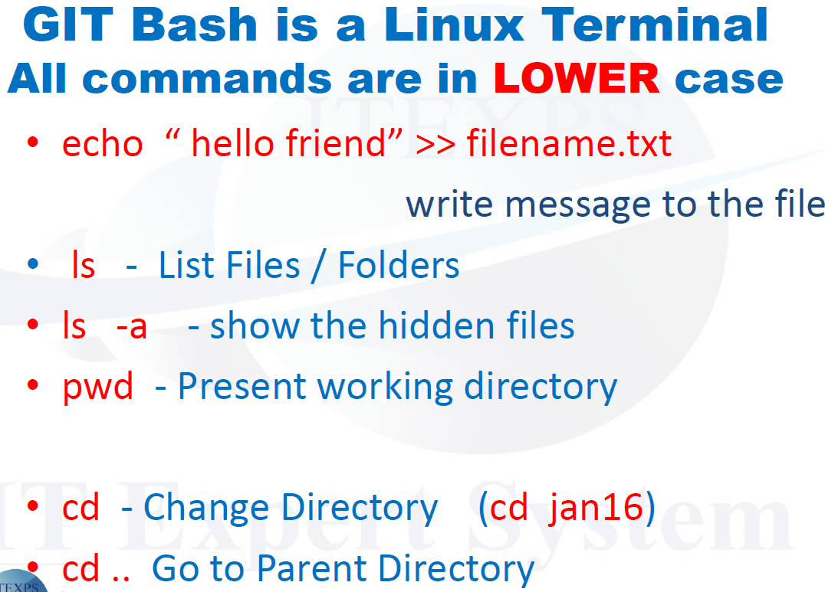 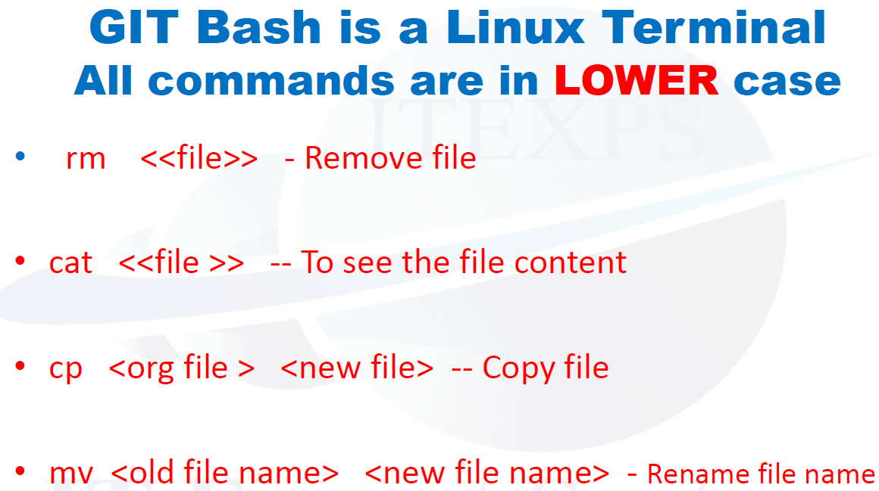 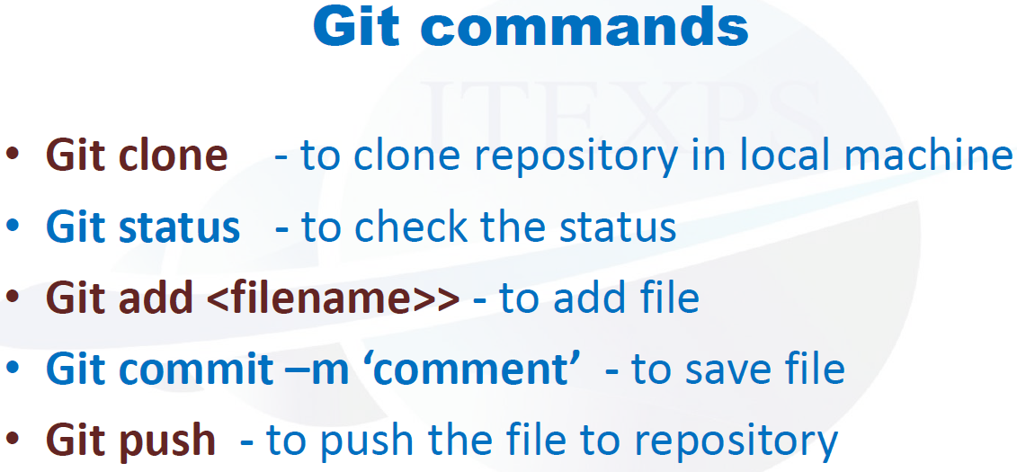

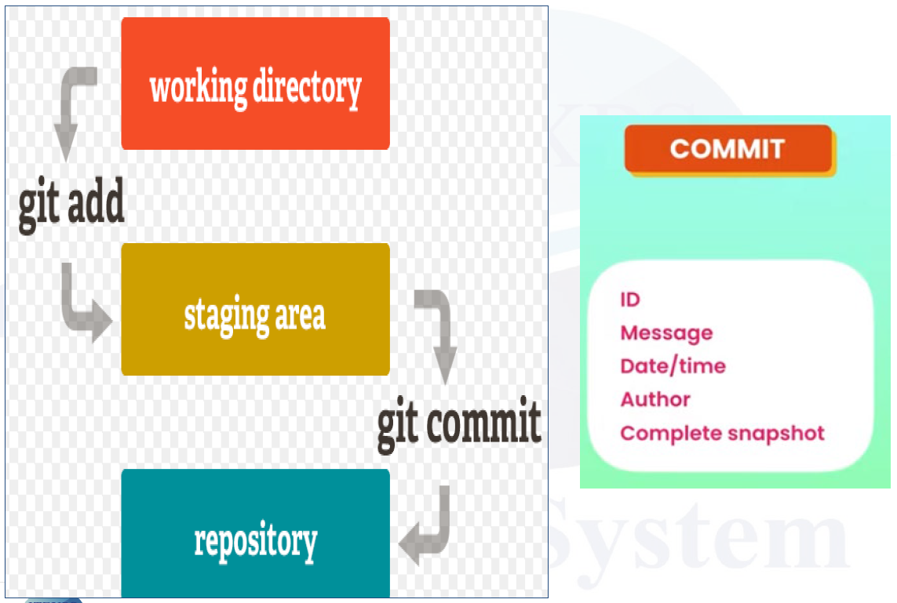 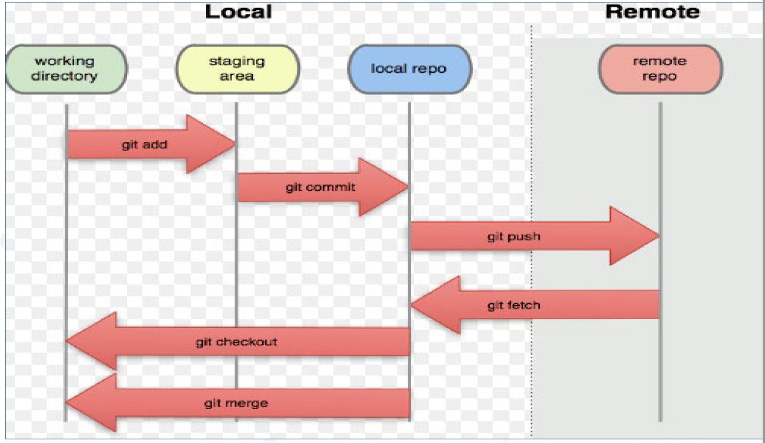

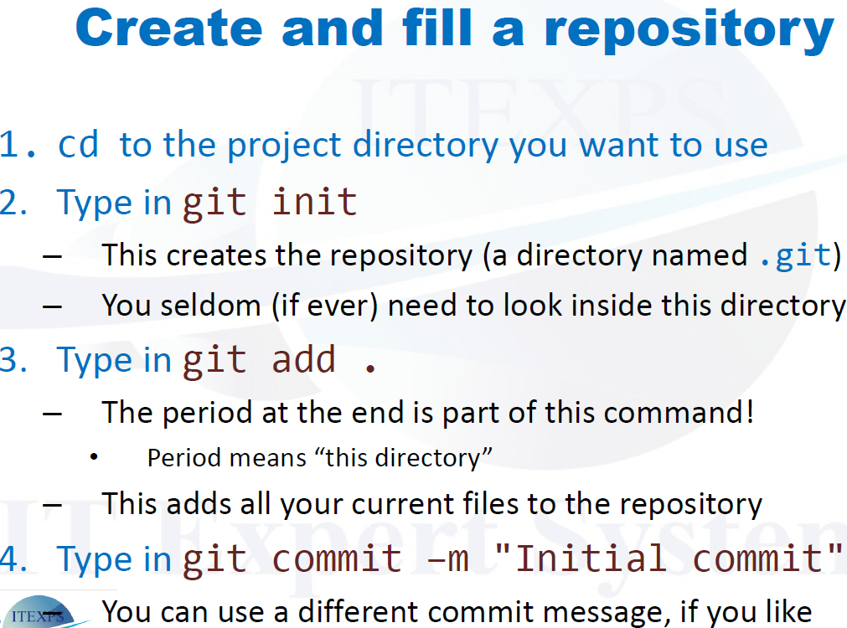 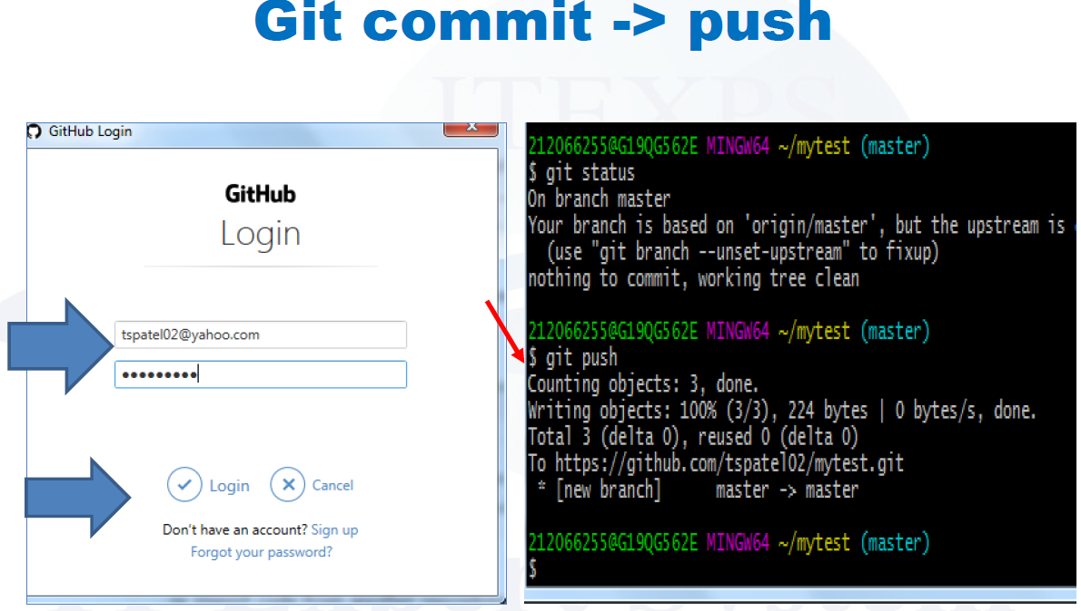

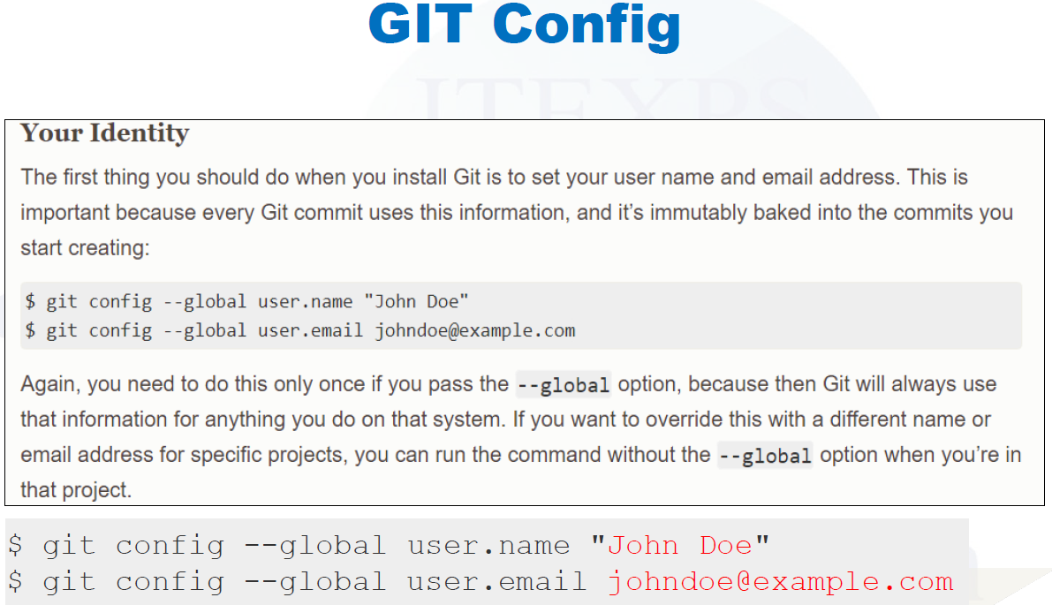

=============================================================

Clear will clear the screen.

ls if you want to see the list of the file and folder.

pwd – print working directory – where am I.

echo “this is gift”> mygit (will create a file – inside double quotes write a statement and close by > followed by file name

you chose to give) here > means write and >> means append (append maintain the last

message)

cat msg to see the message I wrote in echo message.

cat mygit means content.

ls my* ls helps to see files and folders.

git status

git clone copy url from git hub and paste here.

cd jun51 and enter (to go inside the folder) cd stands for change directory.

ls

pwd (allows you to see the folder)

git status (at this point everything should be good to go; no issues)

ls

git pull

clear – clears screen.

>>>>>>>>>>>>>>>>>>>>>>>>>>>>>>>>>>>>>>>>>>>

Create git hub account -> create a repository -> drag a file there from our download folder -> file must be saved as .txt

Now work on git bash

git clone (this will create a folder) use this command followed by URL from git hub -> enter

copy from server and bring it too local.

cd name of the file -> type the repository name – helps to go to the directory.

pwd

echo “type statement here”> type the file name we want

ls will list file and folder.

git status ( will give the name (second) in red or green color)

git add. (want to add the file & don’t want to give the name -> type git add .(dot)

git status

git commit followed by -m “text” and hit enter – copy in my machine which is staging.

git push it will ask user name and password one time and then it establish the connection from your

local machine to cloud and then it will push the file to cloud from git bash. Then refresh the git

hub page and it will add the file to the repository over there.

git pull this command will pull the file from the cloud to the local machine.

git fetch will bring the file to local.

rm filename.txt this will remove the file.

Always remember the after you finish or you must go home always remember adding, commit and push